**Our Energy Future**

**Energy by the Numbers**

Below are a few estimates of energy usage per person in the United States.

* The US uses roughly 20 million barrels of oil per day
* With ~300 million people in the US, each person uses a barrel of oil of energy every 15 days.
* However, oil only constitutes 35% of all US energy consumed. Therefore, a person uses the amount of energy found in a barrel of oil in roughly 5 days.
* A barrel of oil contain roughly 6 Gigajoules (GJ) of energy, which is equivalent to 1700 kilowatt hours (kWh) or 6 MBTUs (Million British Thermal Units)
  + 1 BTU is the amount of energy required to increase the temperature of a pint of water by 1 degree Fahrenheit

As mentioned in prior notes, *power* is equal to some unit of energy / a unit of time. 1 watt is equal to 1 joule per second. Using the above figures of 6 GJ over 5 days, you can arrive at the following rough estimation:

*The average person in the US uses 10,000 watts (10 kW) per hour, or 240 kWh per day*

To put this in perspective, this amount of power is equivalent to 6 household appliances (blowdryers, microwaves, space heaters, etc) running continuously

Compartmentalizing this usage further, we can take a look at energy usage by *household* (not by person). On a daily basis, the typical American household uses:

* 35 kWh in electricity – But that only equates to *delivered* power. In order to deliver the 35 kWh per day, 95 kWh are required to deliver that amount of power to a household.
* 35 kWh in natural gas
* 2.9 gallons of gasoline (36 kWH per gallon, or 105 kWh)

This equals 235 kWh per household, but household usually have more than one person, the average household has ~2.5 people, resulting in 95 kWh per day per person. Where does the other 145 kWh come from?

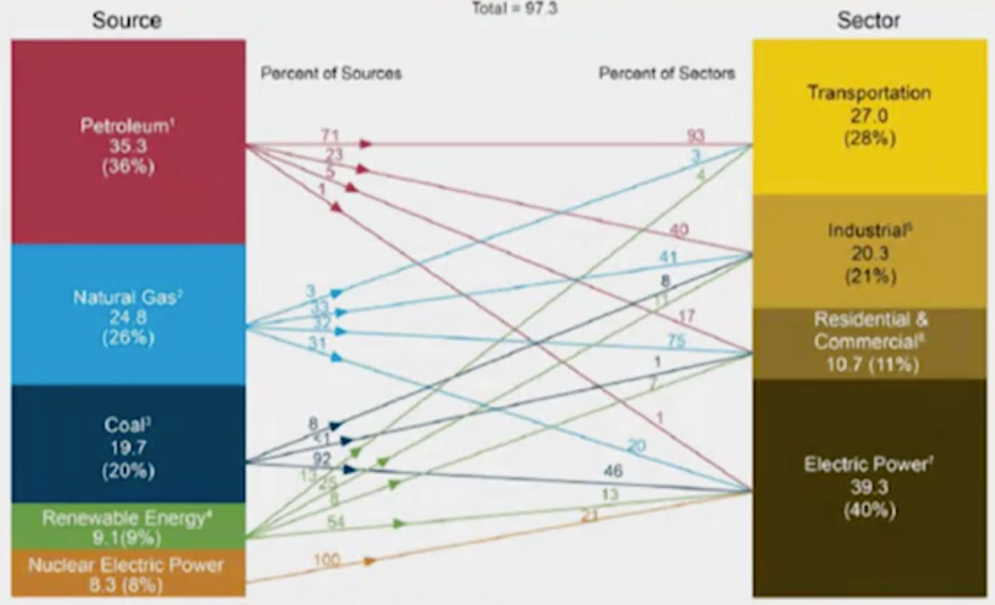The answer lies in the infrastructure that is in place in the US to support our standard of living. Agriculture, industry, transportation, defense, government, commercial activity all happen on our behalf, and all use energy to perform the associated tasks on our behalf.

Below is a graph (from 2011) about different sectors of the US economy and the sources they use for their energy needs.

*What about the rest of the world?*

The entire US uses roughly 3 terawatts (TW) at any given moment in time, and comprises ~20% of global energy consumption (despite being < 5% of the population). This indicates that the instantaneuous energy demand for the world is in the ballpark of 15 TW.

If the world had the same standard of living as the US however, the global instantaneous demand for energy would be ~100 TW.

*Where could we potentially acquire that amount of energy?*

To start to figure out if we can meet that demand through renewables we should look at the amount of energy potential is being generated by renewables:

* Solar: 20,000 TW
* Entire biophysical web is ~60 TW (probably 5-10 of which can be converted to usable energy by humans)
* Wind: 5-10 TW
* Hydroelectric: ~5 TW
* Waves: < 3 TW
* Tidal: 2 TW
* Geothermal: Niche availability

Nuclear is also a possibility but it isn’t renewable because it mines things from the ground and has a finite lifetime

*What other factors do we need to consider when thinking about the mix of energy sources?*

The previous section deals only with abundance, but there are other attributes that energy sources possess which make each more/less likely to scale to meet the energy demands of 100 TW.

Below are all questions we need to consider when trying to figure out if a particular type of energy source can provide sufficient power to humanity.

* How difficult is it to capture energy?
* Is it intermittent?
* How easily is it to transport?
* Is the technology demonstrated or theoretical?
* How accepted is it in the eyes of the public?
* Are people able to capture energy themselves?
* How efficient is the energy source?